Realtime Autonomous Navigation in V-Rep based static and dynamic environment using EKF- SLAM

UmmeHani¹, Lubna Moin²
^{1,2}Department of Electrical Engineering, National University of Science & Technology, Pakistan

Article Info |  | ABSTRACT
Article history:  Received Jun 9, 2018  Revised Nov 20, 2018  Accepted Dec 11, 2018 |  | Localization in autonomous mobile robot allows it to operate autonomously in an unknown and unpredictable environment with the ability to determine its position and heading. Simultaneous Localization and Mapping (SLAM) is introduced to solve the problem where no prior information about the environment is available either its static or dynamic to achieve standard map-based localization. The primary focus of this research is autonomous mobile robot navigation using EKF- SLAM environment modeling technique which provides higher accuracy and reliability in mobile robot localization and mapping result. In this paper EKF-SLAM performance verified by simulations performed in static and dynamic environment designed in V-REP i.e, 3D Robot simulation environment. In this work SLAM problem of two wheeled differential drive robot i.e, Pioneer 3-DX in indoor static and dynamic environment integrated with Laser range finder i.e, Hokuyo URG-04LX-UG01, LIDAR and Ultrasonic sensors is solved. EKF-SLAM scripts are developed using MATLAB that is linked to V-REP via Remote API Feature in order to evaluate EKF-SLAM performance. The reached results confirm the EKF-SLAM is reliable approach for real-time autonomous navigation for mobile robots in comparisons to other techniques.
Keywords:
EKF-SLAM
Obstacle Avoidance
Path Estimation
V-REP
Static and Dynamic Environment Comparison

 |  | This is an open access article under the CC BY-SA license.
Corresponding Author:
Umme Hani,
Department of Electrical Engineering,
National University of Sciences and Technology,
PNEC Road, PNS Jauhar Karsaz Faisal Cantonment, Karachi.
Email: umme.hani2017@pnec.nust.edu.pk

- INTRODUCTION
Autonomous mobile robots navigation is considerably matter of contention from last two decades. Researchers and Scientists are putting prodigious efforts to find reliable solution with the help of Artificial Intelligence and Computer Vision. The applications of Mobile Robots are proficient with degree of self-sufficiency and the criteria of its autonomy are sensing the environment, self-maintenance, task performing, autonomous navigation that includes indoor and outdoor navigation while in cluttered environments reliable data association is important [1],[5] because wrong data association can have catastrophic consequences.
Current SLAM approaches include Graph-SLAM method, Particle Filtering method (PF), Scan Matching method (SM) and the Extended Kalman Filter method (EKF). The Graph-SLAM method takes the SLAM problem as an optimization problem [3]. The objective function and constraints are defined, and it is solved using mathematical programming method. The PF method is recursive Bayesian estimator for dynamic Bayesian networks that approximates the PDF i.e. probability density function by searching for cluster of random samples, uses the sample mean to replace the integral operations, and acquire the variance distribution of the state [2]. It has special advantage in dealing with status filtering of parameter estimation of non-Gaussian and nonlinear time-varying systems while the major drawback is in high-dimensional spaces sampling that can be inefficient. The SM method minimizes the metric distances between the scan characteristics or original data, and aligns the overlap of the scanning datasets [4]. SLAM process leads to better navigation in dynamic environment autonomously. However, lack of proprioceptive feedback from autonomous mobile robot may cause trouble in autonomous operation of robot in unpredictable and unknown environments. Above mentioned issues are some basic problems of SLAM. Now a days, many researchers analysis different approaches to solving problems in SLAM and it is analyzed that the approach based on Extended Kalman Filter (EKF) among all approaches are the most commonly used to solve SLAM problems. Castellanos et.al [6] uses LabMateTM to show robot navigation in indoor environment with integrated use of laser rangefinder sensor.
EKF-SLAM is one of the probabilistic approach to control uncertainties of any mobile robot [10],[13],[16] is most widely used in mobile robotics, especially in SLAM. Moreover, the SLAM filtering solution, which is based on the Extended Kalman Filter (EKF) application is the first successfully implemented [3],[8],[18] and most often used Online SLAM algorithm. There are many theoretical and practical works dedicated to EKF usage with different approaches [5],[11],[20] and application fields [15],[19]. In the autonomous robot navigation, the Extended Kalman Filter based SLAM is categorize as non-linear SLAM, where linearization of non-linear models along with summation of system noise with Gaussian filter takes place so that Kalman filter algorithm can be applied. In comparison with Kalman filter, EKF-SLAM represents the non-linear models which is essential part of all navigation problems almost. EKF-SLAM estimates mobile robot location as it is moving using incremental maximum likelihood estimator, it generates the map by localization and generated map information uses to update its current states and map simultaneously [12].
In this work, EKF-SLAM algorithm has been successfully implemented using a Pioneer 3-DX i.e. a small lightweight two-wheel differential drive mobile robot. The algorithm is implemented and its performance is analyzed in a clustered environment created on V-REP. Lidar sensor interfaced with robot model and the output of robot motors, sensors is then integrated with Matlab to apply algorithm and observe its performance in static and dynamic environment.

- RESEARCH METHOD
The mobile robot model predicts the current states on the basis of control input and previous states of the robot. Mathematically, the process model in the discrete form can be written as ( 1 ) . The robot position (x, y) and orientation angle i.e., Ө estimated the robot states in this research work. It can be shown in the form of state vector as ( 2 ). In this research work speed and angular velocity is applied as control input can be exhibit as in ( 3 ).
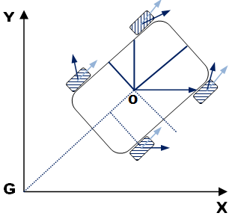
Figure 1. Robot Model
R _{(n+1)} =𝑓(R _{(n),} u_{(n)}) | ( 1 )

R = $\left[\begin{matrix}x \\ y \\ θ\end{matrix}\right]$ | ( 2 )

𝐮 _{(n)} =$\left[\begin{matrix} v_{(n)} \\ ω_{(n)}\end{matrix}\right]$ | ( 3 )

In discrete time, iteratively for every n^{th} sample the predictive state of robot is predicted in sample time T, which capture in time (n .T).
Since the control input to the robot models are speed and angular velocity that are measured and used to predict robot states in this process. The discrete time robot kinematics model for the above case is expressed in ( 4 ).
$$R_{\left(n+1\right)}=\left[\begin{matrix}x_{(n+1)} \\ y_{(n+1)} \\ θ_{(n+1)}\end{matrix}\right] \left[\begin{matrix}x_{(n)} \\ y_{(n)} \\ θ_{(n)}\end{matrix}\right]+T\left[\begin{matrix}v_{\left(n\right)}.cos(θ_{(n)}) \\ v_{\left(n\right)}.sin(θ_{(n)}) \\ ω_{(n)}\end{matrix}\right]$$ | ( 4 )

Robot Model Jacobian can be represented in equation as,

$$R_{\left(n+1\right)|n}= R_{\left(n\right)|n}+T\left[\begin{matrix}v_{\left(n\right)}.cos({R(3)}_{\left(n\right)|n}) \\ v_{\left(n\right)}.sin({R(3)}_{\left(n\right)|n}) \\ ω_{(n)}\end{matrix}\right]$$ | ( 5 )

Ideally, current states of robot can be estimated accurately by using above robot kinematics model but in practical it is influenced by errors that can be noise in measurement of sensors and friction. Equation ( 1 ) with addition of noise model can be written as ( 6 ).

R_{(n+1)}=𝑓(R_{(n)},u_{𝑚(n)}+𝛿𝑢_{(n)}) ≡ 𝑓(R_{(n)},u_{𝑚(n)})+𝛿𝑓 | ( 6 )

In the above case, noise model is estimated as Gaussian noise with zero mean represented by 𝛿𝑓. The covariance of this system noise originated during from the measurement process can be calculated as it can be seen in equation ( 7 ).

𝑄_{𝑓}=𝐹_{𝑢}.𝑄_{𝑢}.𝐹_{𝑢}^{T} | ( 7 )

In which:
𝑄𝑓 = Covariance of Process noise
𝑄𝑢 = Covariance of Control input measurement
𝐹𝑢 = 𝛿_{𝑓}𝛿_{(𝑣,𝜔)}

The Process model Jacobian matrices with respect to the control input measurement 𝐹_{𝑢} and robot states 𝐹_{R𝑣} can be expressed in ( 8 ) and ( 9 ), respectively.

$$F_{u}=\frac{δf}{δ(x, y,θ )}= \left[\begin{matrix}1 & 0 & -T.v_{\left(n\right)}.sin(θ_{(n)}) \\ 0 & 1 & T.v_{\left(n\right)}.cos(θ_{(n)}) \\ 0 & 0 & 1\end{matrix}\right]$$ | ( 8 )

$$F_{u}=\frac{δf}{δ(v,ω )}= \left[\begin{matrix}T.cos({R(3)}_{(n)}) & 0 \\ T.sin({R(3)}_{(n)}) & 0 \\ 0 & T\end{matrix}\right]$$ | ( 9 )

3.1. SLAM Operation Based on 2D-EKF

The SLAM process flow in this research work can be observed on Figure. 2. In contrast to EKF localization SLAM operation involves initialization of landmarks to update robot position.

Initial States & Covariance

No
Updated states and covariance
Prediction
Prediction of states based on process model
Robot Moving
Any Known landmarks?
Update of states and covariance based on current map and observation
Yes
Any new landmarks?

Initialization of landmarks
Yes
No
Updating

Figure 2. 2D EKF-SLAM Operation
The states during the process that are estimated consist of estimated landmarks and robot states. Point landmarks are used in this research, which have two-dimensional (x and y) states. Equation ( 10 ) exhibits the SLAM operation based whole estimated states vector [8]. The mobile robot states (x, y, θ) are correlated by $R_{V}$ and set of landmark states ($L_{x_{1}}$,$L_{y_{1}}$,$L_{x_{2}}$,$L_{y_{2}}$,…,$L_{x_{n}}$,$L_{y_{n}}$) are correlated by $R_{1}$ , with n is the registered landmark number. Similar to the localization process, in which Extended Kalman Filter is used to estimate the states and Gaussian variables including covariance matrix P and mean i.e. expected value of state vector are used to model all the process. The correspondent of expected value of state vector and its covariance matrix P can be shown in equations ( 11 )and ( 12 ). These two matrices expand every time in size with initialization of landmark process, whenever the mobile robot detects new landmark.

$R= \left[\begin{matrix}R_{V} \\ R_{1}\end{matrix}\right]= \left[\begin{matrix}x \\ \begin{matrix}y \\ θ \\ \begin{matrix}L_{x_{1}} \\ L_{y_{1}} \\ ⋮\end{matrix}\end{matrix} \\ \begin{matrix}L_{x_{n}} \\ L_{y_{n}}\end{matrix}\end{matrix}\right]$ | ( 10 )

$$R= \left[\begin{matrix}\overline{R_{V}} \\ \overline{R_{1}}\end{matrix}\right]= \left[\begin{matrix}\overline{R_{V}} \\ \begin{matrix}\overline{L_{1}} \\ . \\ .\end{matrix} \\ \overline{L_{1}}\end{matrix}\right]$$ | ( 11 )

$$P= \left[\begin{matrix}P_{X_{v}, X_{v}} & P_{X_{v}, X_{1}} \\ P_{X_{1}, X_{v}} & P_{M, X_{1}}\end{matrix}\right]$$ | ( 12 )

$$P= \left[\begin{matrix}\begin{matrix}P_{X_{v}, X_{v}} \\ P_{L_{1}, X_{v}} \\ .\end{matrix} & \begin{matrix}P_{X_{v}, L_{1}} \\ P_{L_{1}, L_{1}} \\ .\end{matrix} & \begin{matrix}\begin{matrix}. & . & P_{X_{v}, L_{n}}\end{matrix} \\ \begin{matrix}. & . & P_{L_{1}, L_{n}}\end{matrix} \\ .\end{matrix} \\ . & . & . \\ P_{L_{1}, X_{v}} & P_{L_{1}, X_{v}} & \begin{matrix}. & . & P_{L_{n}, L_{n}}\end{matrix}\end{matrix}\right]$$ | ( 13 )

3.2. 2D EKF-based SLAM Process General Operation
3.2.1. Step 0. Robot Initialization
At the initial time (t=0), only the robot states are initial states, and no landmark is registered to the map. Although, P = P0 can be considered as the covariance matrix as the robot initial state is assumed to be known so that there is no uncertainty.
$\overline{R}= \overline{R_{V}}= \left[\begin{matrix}x \\ y \\ θ\end{matrix}\right]= \left[\begin{matrix}0 \\ 0 \\ 0\end{matrix}\right]$ $P= \left[\begin{matrix}0 & 0 & 0 \\ 0 & 0 & 0 \\ 0 & 0 & 0\end{matrix}\right]$ | ( 14 )
3.2.2. Step 1. Prediction Step
3.2.2.1. Updating Robot States
The mobile robot movement affects the robot states only and based on the robot process model and its movement, the new estimated robot state ($R_{V}$) as in equation ( 15 )and the landmark state ($R_{1}$) as in equation ( 16 ) can be predicted.
$\overline{R_{V}} ← f_{R_{v} }(\overline{R_{V}} , u ,\overline{N})$ | ( 15 )
$$\overline{R_{1}} ← \overline{R_{1}}$$ | ( 16 )

Equation ( 15 ) correlates to the robot process model equation ( 4 ) based on its control input (u), previous state ($R_{V}$) and noise model (N) while N̅ is equal to zero as the noise in this process is modeled in as white noise.
3.2.2.2. Robot Covariance Updating
The updated covariance P in this process based on model prediction is calculated as in equation ( 17 ) , where as correspond to the process model equation, $F_{R }$ is the Jacobian of the state and Pn is the measurement input control noise covariance.
$$P ← F_{R }P{{ F}_{R }}^{T}+ Pn$$ | ( 17 )
As mentioned previously, states of the robot (R̅) only affected by the robot movement so the covariance matrix P related to the robot states affects the Jacobian matrix to update. Therefore, in this process the Jacobian matrix is calculated as in equation ( 18 ), in which 0 corresponds to zero matrices and I correspond to the identity matrix.
$F_{x}= \left[\begin{matrix}\frac{df_{R}}{dR} & 0 \\ 0 & I\end{matrix}\right] Pn= \left[\begin{matrix}\frac{df_{R}}{dN} \\ 0\end{matrix}\right]$ | ( 18 )

3.2.3. Step 2. Landmark Based Observation Updating Process
The mobile robot observes around the landmark while it is moving using the laser sensor that measures observable landmarks range and bearing related to the robot orientation and position. If the observed landmark is already registered to the map, its range and bearing measurement are used to update the states estimation ($\overline{R}$) and also its covariance (P). The measurement process and its corresponded covariance modeled as in equation ( 19 ) and ( 20 )are independent for each landmark (i). The state updating process based on observed landmarks is processed one by one of each landmark.
$$\overline{z}= y_{i}- h_{i} (R_{V} , L_{i})$$ | ( 19 )
$$H_{R}= \left[\begin{matrix}H_{R_{v}} & \begin{matrix}0 & … & \begin{matrix}0 & H_{L_{i}} & 0 \end{matrix}\end{matrix} & … 0\end{matrix}\right]$$ | ( 20 )
$$H_{R_{v}}= \frac{δh_{i }(\overline{R_{V}},\overline{L_{i}})}{δ R_{V}} ; H_{L_{i}}= \frac{δh_{i }(\overline{R_{V}},\overline{L_{i}})}{δ L_{i}}$$ | ( 21 )
Based on the Jacobian (see equation ( 20 )) and above measurement model , the updated state process and its updated covariance based on a set of equation ( 22 ) into equation ( 26 ) are calculated, in which K in this updating process is Kalman gain.
$$\overline{z}= y_{i}- h_{i} (R_{V} , L_{i})$$ | ( 22 )

$$Z= H_{X} P{H_{X}}^{T}+ R$$ | ( 23 )

$$K= P{H_{X}}^{T}Z^{-1}$$ | ( 24 )

$$\overline{R} ←\overline{R}-K\overline{z}$$ | ( 25 )

$$P ←P-KZK^{T}$$ | ( 26 )

3.2.4. Step 3. Initialization of Landmarks
When the landmarks for the first time are observed by the robots have not registered on the map. Whereas, based on its range and bearing measurement the state of this new landmark is estimated including x and y global coordinate corresponding to the robot state R. The new landmark estimated states function can be exhibit as equation ( 27 ) are calculated as the invert of observation function ($h_{i}$ (R,$L_{i}$)) while the new landmark states corresponding Jacobian, the inverse observation function and the robot states are written as equation ( 28 ).
$${\overline{L}}_{n+1}=g ({\overline{X}}_{V }, {\overline{y}}_{n+1})$$ | ( 27 )

$$G_{X_{v}}= \frac{∂g ({\overline{X}}_{V }, {\overline{y}}_{n+1})}{∂ X_{V}} ; G_{L_{i+1}}= \frac{∂g ({\overline{X}}_{V }, {\overline{y}}_{n+1})}{∂ L_{i+1}}$$ | ( 28 )
The new landmark covariance and cross covariance are calculated based on equation ( 29 ) and ( 30 ) related to the prior states.
$$P_{LL }= G_{X_{v}}P_{LL }{G_{X_{v}}}^{T}+ G_{y_{n+1}}X_{v }{G_{y_{n+1}}}^{T}$$ | ( 29 )

$$P_{LX }= G_{X_{v}}P_{LL }P_{X_{v}X_{1}}$$ | ( 30 )

On the basis of estimation result, these new landmark states and its covariance are then summed into the robot full state, map and covariance as in equation ( 31 ).
$$\overline{X} ← \left[\frac{\overline{X}}{L_{n+1}} \right] P← \left[\begin{matrix}P & {P_{LX}}^{T} \\ P_{LX} & P_{LL}\end{matrix}\right]$$ | ( 31 )

- RESULTS AND ANALYSIS
To analyze the performance of EKF-SLAM algorithm for autonomous mobile robot navigation realization, indoor environment with static and dynamic objects was designed on V-REP simulator that was connected with Matlab via Remote API features while two wheeled differential drive robot i.e., Pioneer 3-DX integrated with Laser range finder i.e., Hokuyo URG-04LX-UG01 to determine its performance effectiveness with integration of LIDAR and ultrasonic sensors. EKF- SLAM algorithm is developed using MATLAB that is linked to V-REP via Remote API Feature. In order to evaluate EKF- SLAM performance.
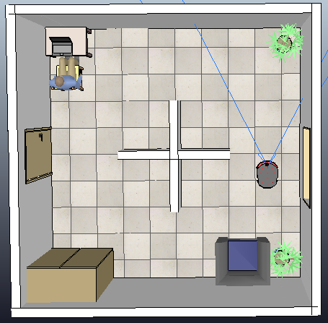
Figure 3. Environment with static objects designed on V-REP
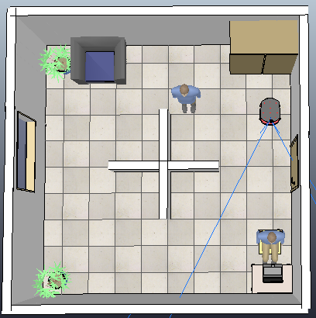

Figure 4. Environment with dynamic objects designed on V-REP

Simulation was performed on V-REP Simulator settings i.e., Simulation time step dt =50 ms, Dynamics Engine = Bullet 2.78, Dynamic Settings = Accurate. When the simulation begins mobile robot starts scanning with 2D laser range finder “Hokuyo URG-04LX-UG01” that allows wide scanning range of 5600mm×240° for measurement of the landmarks in indoor environment that integrated to the robot and avoid obstacles with the help of EKF- SLAM algorithm. In an experiment, the exploration is simulated in a room bounded by 240 cm high walls, 80cm walls in centre, chair, table, cupboard and rack by a Pioneer 3-DX robot equipped with a mid-noise and odometry 2D range scanner i.e., Hokuyo URG-04LX-UG01. Gaussian noise distributed in polar coordinates. Iterative Closet Point (ICP) algorithm is used for Data association [7] i.e., performed at each step and exploration performed with Braintenberg, Lyapunov, ZigZag and Cornering algorithms [9] which maximize performance. It has been observed that uncertainty is the critical measurement parameter of performance degradation which affects measurement models and motion due to its direct influence consistency.
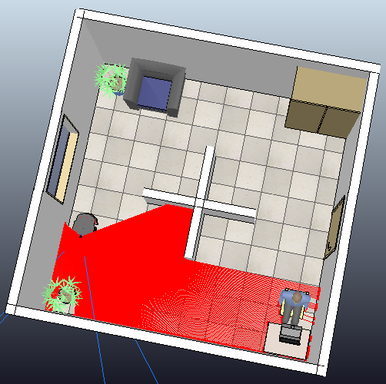
Figure 5. Scanning with static objects on V-REP Simulator
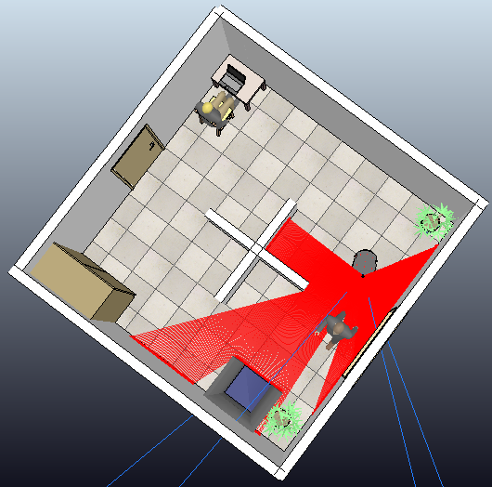
Figure 6. Scanning with dynamic objects on V-REP Simulator

Graphical User Interface (GUI) designed on Matlab which was interconnected with V-REP simulator. As the simulation starts, robot motion navigation tracked on V-REP simulator and Matlab GUI simultaneously. The Landmarks are pointed with red cross while robot was represented with small triangle. Run Time set at 3000 s.

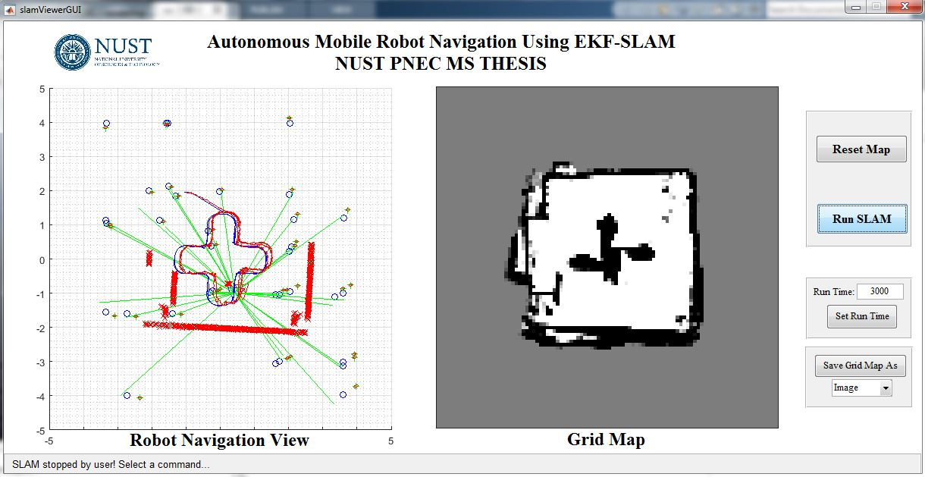
Figure 7. Matlab GUI for Robot Navigation

As the robot moves it find observed landmarks, avoid obstacles, update states and covariance matrices based on current map and observation. If any new landmarks are found, it initializes updated states and covariance. While the robot motion tracked on Grid Map (see Figure. 8, Figure 9).

Grid Maps are introduced in 1985 by Moravec and Elfs, that represents environment by grid, assuming robot position is known and occupancy of individual cell is independent stores the posterior probability that a location or corresponding area is occupied by an obstacle, larger value represents obstacle marked by black color and smaller value represents free space marked by white color.

Accurate mapping can be achieved by combining lots of data while each cell in grid represents a bit of robot’s environment indicate some measure of “obstacleness” in each grid cell based on laser sensor readings while algorithm operates if the sensor data has been obtained directly from a laser scanner and using only the odometry [19],[17].

Figure 8. Grid Map of Environment with static objects | Figure 9. Grid Map of Environment with dynamic objects

In the Robot Navigation view, green lines represents Lidar sensor exploration, Red and Blue triangles indicate a mobile robot, blue circles represents landmarks and red cross indicates estimated landmarks (see Figure 10 and Figure 11 ).

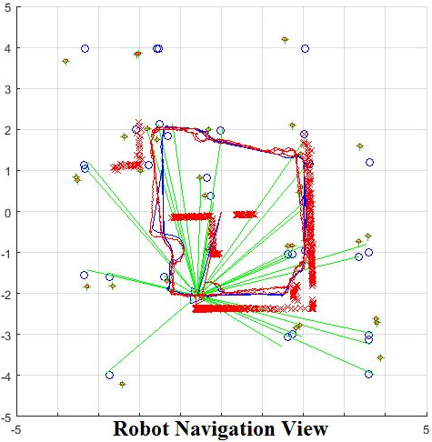 | 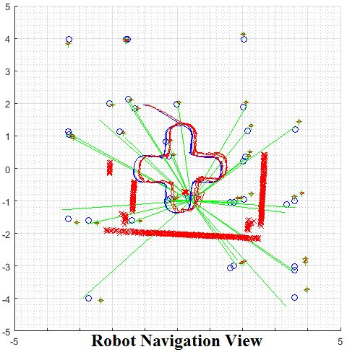
Figure 10. Navigation View with Static Objects | Figure 11. Navigation View with Dynamic Objects

The performance of the proposed EKF-SLAM algorithm in indoor environment with static and dynamic objects observed and compared in terms of standard deviation of the vehicle heading and it was observed that the uncertainty in position over time is better than usual SLAM results exhibit in Figure 12 and Figure 13. It was observed that the uncertainty in position over time observed by plotting Standard Deviation of position (m) on y axis and Time(s) on x axis.

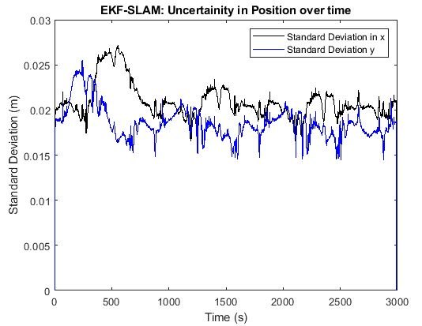 | 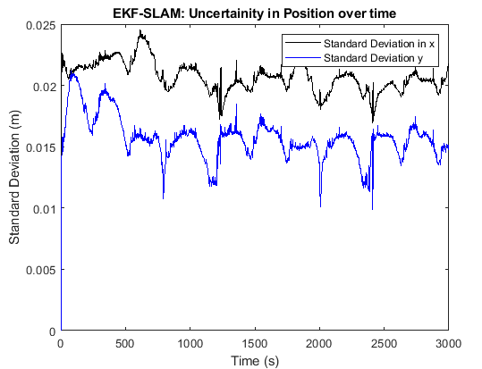
Figure 12. Uncertainty in Position over time with static objects | Figure 13. Uncertainty in Position over time with dynamic objects

Table 1. Simulated Uncertainty in Position over time with Static and Dynamic Objects
Uncertainty in position over time | With Static objects |  | With Dynamic objects
 | Position(m) | Time (s) | Position(m) | Time (s)
Maximum Standard Deviation in x | 0.0278 | 612 | 0.02455 | 615
Minimum Standard Deviation in x | 0.0175 | 255 | 0.01693 | 2410
Maximum Standard Deviation in y | 0.0258 | 425 | 0.02145 | 77
Minimum Standard Deviation in y | 0.0163 | 2917 | 0.00987 | 2412

EKF-SLAM performance and accuracy can also be estimated by plotting error in position over time. Uncertainty in robot navigation can be computed by considering noise and Jacobians. Figure 14, Figure 15 represents error in position over time in designed indoor environment with static and dynamic objects respectively. It was observed at turning positions inside room there are spikes after certain instant of time and more spikes observed in simulation with dynamic objects at certain instant of time. In our controlled simulation environment we have compared the performance of the map joining and the consistency of mapping algorithm while for some trajectory points discrepancies are observed furthest from the initial location of the vehicle.

When mobile robot heading position estimated by odometry, Figure 16 and Figure 17 represents odometry error over time by plotting Position error (m) and Angular error (rad) on y-axis versus time on x-axis. The mobile robot corrects its own position by updating landmarks.

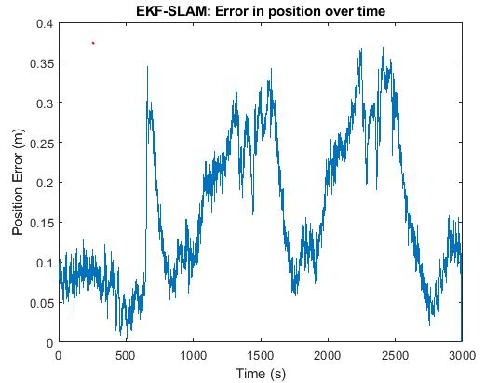
Figure 14. EKF-SLAM - Error in position over time
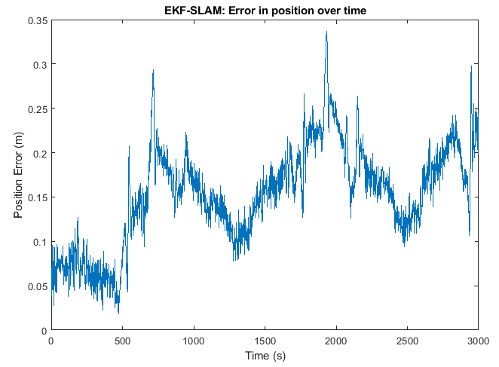
Figure 15. EKF-SLAM - Error in position over time
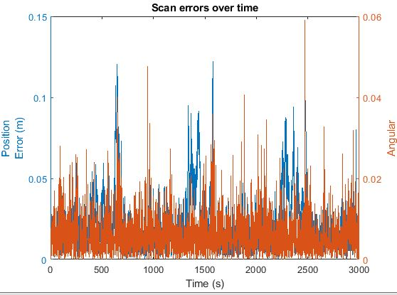
Figure 16. Scan errors over time with static objects
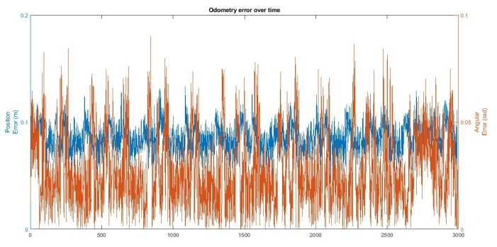
Figure 17. Odometry Error over time with static objects
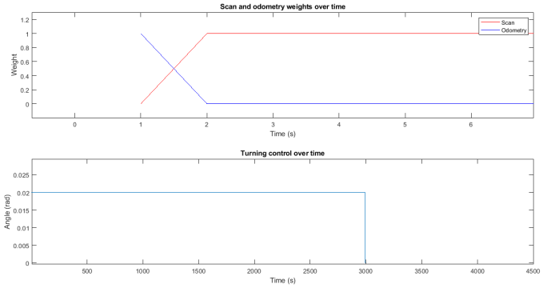
Figure 18. Scan Odometry weights and Turning control over time

Table 2. Simulation Results of EKF-SLAM algorithm
 | With Static objects |  | With Dynamic objects
 | Position Error | Angular Error | Position Error | Angular Error
Maximum Scan Errors over time | 0.134m at 857 sec | 0.0002281 rad at 1017 sec | 0.08034 m at 2944 sec | 0.0016214 rad at 2757 sec
Minimum Scan Errors over time | 0.056 m at 1907 sec | 0.0939 rad at 1769 sec | 0.0044478 m at 2972 sec | 0.004478 rad at 2972 sec
Maximum Odometry Errors over time | 0.13317 m at 1084 sec | 0.090028 rad at 843 sec | 0.13412 m at 857 sec | 0.093917 rad at 1769 sec
Minimum Odometry Errors over time | 0.05591 m at 828 sec | 0.000158 rad at 2633 sec | 0.05609 m at 1907 sec | 0.000477 rad at 1197 sec

Simulation with static objects and dynamic objects results summarized in Table 2. It can be analyzed that less scan and odometry errors in 3000 seconds simulation time observed with dynamic objects as compared to static objects, although it analyzed that both simulations performed accurate navigation using EKF- SLAM algorithm.

- CONCLUSION
This research represents EKF-SLAM algorithm performance in indoor environment designed with static and dynamic objects on V-REP simulator. It was observed and verified with results that autonomous mobile robot navigates using EKF-SLAM algorithm implemented on Matlab while runtime robot navigation viewed on V-REP which was later linked with Matlab GUI via remote Api commands. The Pioneer 3-DX Mobile robot i.e., equipped with the Lidar and Ultrasonic sensors performed exploration with static and dynamic objects, it was observed through Landmarks measurement that EKF- SLAM corrects odometry error [18, 20]. The simulation verifies that the degradation in odometry error and error in position over time which in results decrease uncertainty in position over time. The robot defines its path by avoiding obstacles and update landmarks if any new landmarks are found during scan.
EKF- SLAM performance observed that robot performs navigation with less position error, scan error and odometry error in indoor environment with static objects as compared to dynamic objects. The suggested EKF- SLAM solves online SLAM problem by using linearized Gaussian probability distribution method. It was supposed as first probabilistic SLAM algorithm. Data Association is one of the challenging problems in navigation in which association between measurements and features is unknown that is solved using EKF- SLAM.
Future work is to estimate algorithm performance for longer time period with reduce computational complexity, through experiment and compare its result with current research findings. However, EKF-SLAM with consistent information for longer period of time still recommended for navigation for its stable results in complex environments and accurate performance.

ACKNOWLEDGEMENTS
This research is supported by the department of Electrical Engineering of Pakistan Navy Engineering College of National Umiversity of Sciences and Technology.

REFERENCES
- P. Roston and Eric P. Krotkov, "Dead Reconing Navigation for Walking Robots," The Robotics Institute , Carnegie Mellon University, Pittsburgh-Pennsylvania, CMU-RI-TR-91-27 1991.
- Joan Sol`a, Simulataneous localization and mapping with the extended Kalman filter, 2014.
- Jaeyong Park, Sukgyu Lee, Joohyun, Park, “Correction Robot pose for SLAM based on Extended Kalman Filter in a Rough Surface Environment,” International Journal of Advanced Robotic Systems, Vol. 6, No. 2 (2009).
- S. Anderson and T. Barfoot, “Towards relative continuous-time SLAM,” in IEEE International Conference on Robotics and Automation (ICRA), Karlsruhe, Germany, May 2013
- Zhang, J., Singh, S. Low-drift and real-time lidar odometry and mapping. Auton Robot 41, 401–416 (2017).
- Luka Teslic ́, Igor Škrjanc, and Gregor Klancˇar, "EKF-Based Localization of a Wheeled Mobile Robot in Structured Environments ," J Intell Robot Syst, June 2010.
- Data Association using Empty Convex Polygonal Regions in EKF-SLAM, Gururaj Kosuru, Satish Pedduri and K Madhava Krishna IEEE International Conference on Robotics and Biomimetics, 2010.
- C.P. Connette, O. Meister, M. Hagele, and G.F. Trommer. Decomposition of line segments into corner and statistical grown line features in an EKF-SLAM framework. In Intelligent Robots and Systems, 2007. IROS 2007. IEEE/RSJ International Conference on, pages 3884–3891. IEEE, 2007.
- Luigi D’ Alfonso,Andrea Griffo, Pietro Muraca, Paolo Pugliese. A SLAM algorithm for indoor mobile robot localization using Extended Kalman Filter and a segment based environment mapping.
- Huang, Y., Zhang, Y., Xu, B., Wu, Z., Chambers, J. A.: A new adaptive extended Kalman filter for cooperative localization. IEEE Transactions on Aerospace and Electronic Systems, vol. 54, no. 1, pp. 353-368. (2018).
- Jiang, Z., Zhou, W., et al. A new kind of accurate calibration method for robotic kinematic parameters based on the extended Kalman and particle filter algorithm. IEEE Transactions on Industrial Electronics, vol. 65, no. 4, pp. 3337–3345. (2018)
- Skrzypczy´nski, P.: Laser scan matching for self-localization of a walking robot in man-made environments. Industrial Robot: An International Journal, vol. 39, No. 3, pp. 242–250. (2012)
- Reina, G., Messina, A.: Vehicle dynamics estimation via augmented Extended Kalman Filtering. Measurement, vol. 133, pp. 383–395. (2019)
- Buratowski, T., Dabrowski, B., Uhl, T., Kwosek, J.: The precise odometry navigation for the group of robots. Schedae Informaticae, vol.19, pp. 99–111. (2015)
- Jesus F. and Ventura R., “Simultaneous Localization and Mapping for Tracked Wheel Robots Combining Monocular and Stereo Vision”, JAMRIS, vol. 7, no. 1, 2013, pp. 21–27.
- Kudriashov, A., Buratowski, T., Giergiel, M.: Robot’s pose estimation in environment exploration process with slam and laser techniques. Naukovi Notatki, vol. 58, pp. 204–212. (2017)
- F. F. Yadkuri and M. J. Khosrowjerdi, “Methods for improving the linearization problem of extended Kalman filter,” Journal of Intelligent & Robotic Systems, vol. 78, no. 3-4, pp. 485–497, 2015.
- Mohamed, S.A.S.; Haghbayan, M.H.; Westerlund, T.; Heikkonen, J.; Tenhunen, H.; Plosila, J. A Survey on Odometry for Autonomous Navigation Systems. IEEE Access 2019, 7, 97466–97486.
- Alejo, D.; Caballero, F.; Merino, L. A Robust Localization System for Inspection Robots in Sewer Networks. Sensors 2019, 19, 4946.
- Jung, D.; Seong, J.; bae Moon, C.; Jin, J.; Chung, W. Accurate calibration of systematic errors for car-like mobile robots using experimental orientation errors. Int. J. Precis. Eng. Manuf. 2016, 17, 1113–1119.

BIOGRAPHIES OF AUTHORS

Umme Hani graduated from NED University of Engineering & Technology, Pakistan, in March 2017 with a Bachelor’s of Engineering in Electronics Engineering. She has a background in Industrial Automation, Artificial Intelligence and Machine Vision based systems designed for Pharmaceutical Industries and holds keen interests in the area of Controls Systems. She is currently enrolled in MS Electrical Control System Engineering at National University of Science & Technology, Pakistan. Her research interests include Instrumentation, Industrial Automation, Machine Vision, Control, Robotics and Computer Vision.
Dr. Lubna Moin received her Ph.D. in Electrical Engineering from National University of Science & Technology in 2017. She is currently designated as an Associate Professor in the Department of Electronics & Power Engineering at National University of Science & Technology, Pakistan. She has published around 20 research articles in leading journals and conference proceedings. She is also a member of IEEE USA and IIIS USA. Her research interests include Modern Control System, Industrial Controls, Machine Learning, Advanced Electronics and Biomedical Engineering.

